**Technical Report: Designing a Cable hanging bridge.**

**Name: Md Sharif Hossain; ID: 1712336642**

**EEE154: Introduction to Engineering Drawing, Section: 13**

**Group: D**

**Introduction:** In this report, the instructions for the designing of a bridge is shown with details demonstration. To sketch the bridge, I started with a reference image which I found in internet. I applied numerous operations on this reference to obtain a complete bridge design. On this Complete Bridge Design project, my part was to sketch side view. My reference image of designing the project is showed below.

**Reference image:**

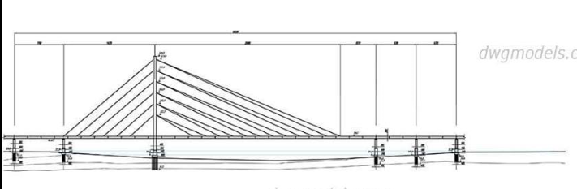

Fig 0.1: Reference Image

**Step 1:** Defining Layers as necessary.

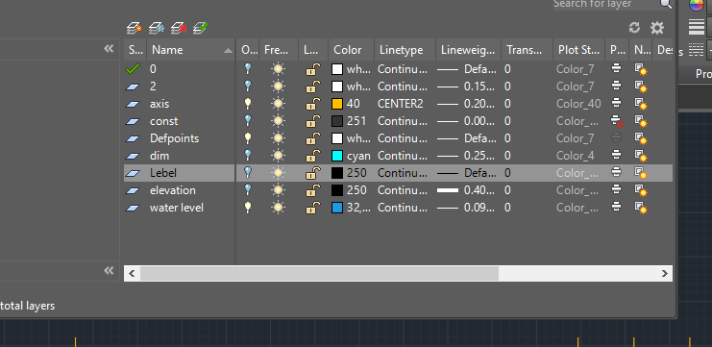

Fig 1: Defined layers

**Step 2:** Plotting axis and water level as construction lines.

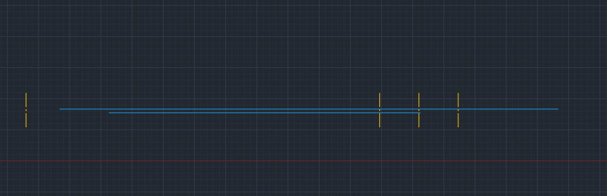

Fig 2: Axis and water level

**Step 3:** Adding pillars in the axis lines.

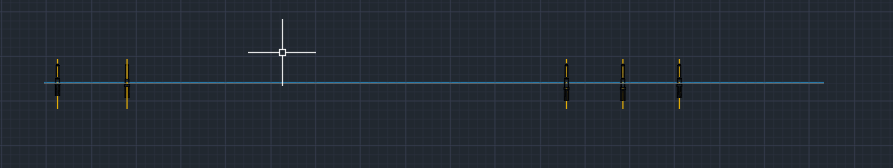

Fig 3: Pillars were added

**Step 4:** Adding street or pathway over the pillars.

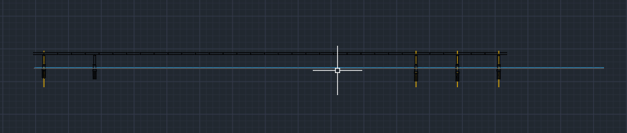

Fig 4: Pathway was added

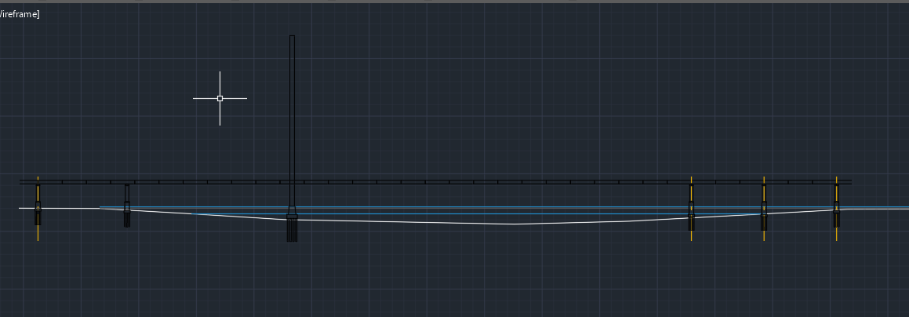**Step 5:** Adding another pillar to hold the cables.

Fig 5: Cable pillar was added

**Step 6:** Adding cables holding the bridge.

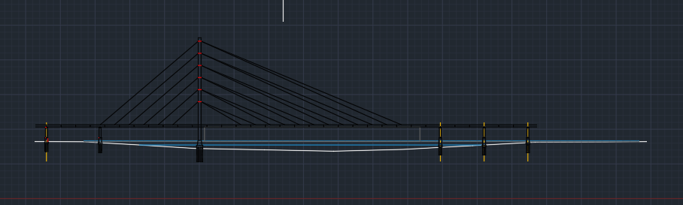

Fig 6: Cables were added

**Step 7:** Semi Final view by adding measurements and comments.

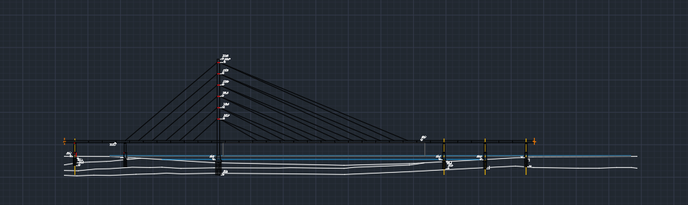

Fig 7: Measurements were plotted

**Step 8:** Final view by adding dimensions.

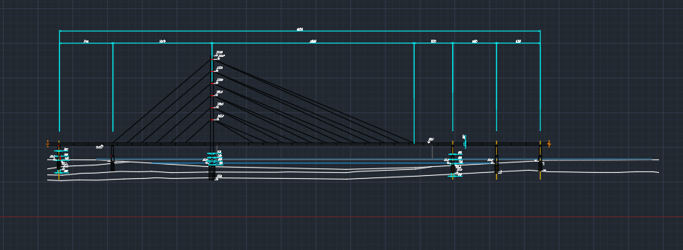

Fig 8: Added Dimension